South China University of Technology
《Course》Experiment Report
Experiment Title： The Design an Analysis of Computer Algorithms
Name： 张杰铖 Student ID： 202030443394
Class： 计科全英联合班 Group： Individual
Collaborator： NO
Teacher： 颜小洋
Description
【Objective and Requirement】
Objective：
Learn to implement various sorting algorithms and analyze and compare their complexity.
Requirement：
The sorting problem with different size are solved using more than 3 kinds of sorting algorithms, and the results on efficiency of different sorting algorithms for different problem sizes should be compared in the graph.

【Environment】
Operating System：Windows 10
Content
【Procedure】
- Step：
- Bubble sort, selection sort, insertion sort, Hill sort, quick sort, merge sort, radix sort and heap sort are implemented in C++ respectively, a total of eight sorts.
- Eight sorting algorithms are called. Each algorithm sequentially sorts a randomly generated random sequence with a scale of 0 to 50,000 and a scale step of 200, and records the time spent by the algorithm for each sorting.
- From step 2, we will get eight arrays that record the time it takes for each algorithm to sort the sequence from small to large out of order, and write them into eight txt files.
- Use Python's seaborn library to make multi-trend line graphs for the 8 txt data obtained in step 3.
- Program (Main)：
#include <iostream>
using namespace std;
#include <queue>
#include <time.h>
#include <fstream>

int MAXSIZE=100;

template <class Elem>
bool Comlt(Elem a,Elem b){
return a<b;
}

template <class Elem>
bool Comgt(Elem a,Elem b){
return a>b;
}

template <class Elem>
void swap(Elem* A,int pos1,int pos2){
Elem temp=A[pos1];
A[pos1]=A[pos2];
A[pos2]=temp;
}

template <class Elem> class max_Heap{
public:
Elem* Heap;
int size;
int n;
max_Heap(int s=MAXSIZE){
size=s;
n=0;
Heap=new Elem[size];
}
max_Heap(Elem* h, int temp_n, int s=MAXSIZE){
size=s;
n=temp_n;
Heap=h;
buildHeap();
}
void shifdown(int pos){
while (!isLeaf(pos)){
int j= leftchild(pos);
int rc= rightchild(pos);
if((rc<n)&&Comlt(Heap[j],Heap[rc])){
j=rc;
}
if(!Comlt(Heap[pos],Heap[j])){return;}
swap(Heap,pos,j);
pos=j;
}
}
int heapsize(){
return n;
}
bool isLeaf(int pos){
return ((pos*2+1)>=n);

}
int leftchild(int pos) const{
return 2*pos+1;
}
int rightchild(int pos) const{
return 2*pos+2;
}
int parent(int pos) const{
return (pos-1)/2;
}
bool insert(const Elem& e){
if(n>=size){return false;}
int curr=n++;
Heap[curr]=e;
while (curr!=0 && Comgt(Heap[curr], Heap[parent(curr)])){
swap(Heap,curr, parent(curr));
curr= parent(curr);
}
return true;
}
bool removemax(Elem& e){
if(n<=0){return false;}
e=Heap[0];
Heap[0]=Heap[--n];
Heap[n]=e;
shifdown(0);
return true;

}
bool remove(int pos,Elem& it){
it=Heap[pos];
Heap[pos]=Heap[--n];
bool flag=true;
while (pos!=0 && Comgt(Heap[pos],Heap[parent(pos)])){
swap(Heap,pos, parent(pos));
pos= parent(pos);
flag= false;
}
if(flag){ shifdown(pos);}
return true;
}
void buildHeap(){
for(int i=n/2+1;i>=0;i--){
shifdown(i);
}
}
};

template <class Elem> class Comp{
public:
static bool lt(Elem a,Elem b){
return a<b;
}
static bool eq(Elem a,Elem b){
return a==b;
}
static bool gt(Elem a,Elem b){
return a>b;
}
};

//此处实现的都是升序

//Bubble sort的特点是前面部分先排好，未来都不会再变动
//其后面也会呈现于由小到大的趋势，但是趋势可能并不明显
template <class Elem>
void Bubble_Sort(Elem* A, int n){
for(int i=0;i<n-1;i++){
for(int j=n-1;j>i;j--){
if(Comp<Elem>::lt(A[j],A[j-1])){
swap(A,j,j-1);
}
}
}
}

//Selection sort的特点是其比Bubble sort少了swap的次数
//但相对的，其后面部分不会呈现趋于由小到大的反映
template <class Elem>
void Selection_Sort(Elem* A,int n){
for(int i=0;i<n-1;i++){
int Min=A[i];
int target=i;
for(int j=n-1;j>i;j--){
if(Comp<Elem>::lt(A[j],Min)){
target=j;
Min=A[j];
}
}
if(target!=i){
swap(A,i,target);}
}
}

//Insertion Sort的特点是每次加入一个新的
//因此前面排好的部分还会不断调整
template <class Elem>
void Insertion_Sort(Elem* A,int n){
for(int i=1;i<n;i++){
for(int j=i;j>0;j--){
if(Comp<Elem>::lt(A[j],A[j-1])){
swap(A,j,j-1);
}
}
}
}

//跳跃的insertion sort，比较抽象
template <class Elem>
void Shell_Sort(Elem* A,int n){
for(int gap=n/2;gap>0;gap/=2){
for(int i=gap;i<n;i++){
int j=i;
Elem current = A[i];
while (j-gap>=0&&Comp<Elem>::lt(current,A[j-gap])){
A[j]=A[j-gap];
j=j-gap;
}
A[j]=current;
}
}
}

inline int findpivot(int i,int j){
return (i+j)/2;
}

template <class Elem>
inline int partition(Elem* A,int l,int r,Elem& pivot){
do{
while (Comp<Elem>::lt(A[++l],pivot));
while ((l<r)&&Comp<Elem>::gt(A[--r],pivot));
//第二个while把r拦下来了，所以最后l会等于r等于第一个大于pivot的数的索引
//在Qsort交换该数字与pivot
//经典的写法是让l成为第一个大于pivot的，r成为最后一个小于pivot的，即不拦住r，swap后在
//退出循环的位置再swap l和r一次还原(l<r)改为(r!=0)
//经典的写法需要swap element多一次，element很大时不佳
//本写法虽然减免了这一次swap，但是swap是自己和自己swap，可能会有bug
swap(A,l,r);
} while (l<r);
return l;
}

//快速排序
template <class Elem>
void Quick_Sort(Elem* A,int left,int right){
if(right<=left){return;}
int pivotindex= findpivot(left,right);
swap(A,pivotindex,right);
int k= partition(A,left-1,right,A[right]);
//由于是++l，--r的写法，所以要输入left-1
swap(A,k,right);
//还原pivot的位置
Quick_Sort<Elem>(A,left,k-1);
Quick_Sort<Elem>(A,k+1,right);
}

//分治排最大的特点是其左边(left到mid)和右边(mid+1到right)的顺序都是排好的
//其需要把left==right的情况放出来(在这里隐含在i2>right的action里)
//其余的只需要用i1，i2做index排列放进更大的匣子即可
template <class Elem>
void Merge_Sort(Elem* A,Elem* temp,int left,int right){
int mid=(left+right)/2;
if(left>=right){return;}
Merge_Sort<Elem>(A,temp,left,mid);
Merge_Sort<Elem>(A,temp,mid+1,right);
for(int i=left;i<=right;i++){
temp[i]=A[i];
}
int i1=left;
int i2=mid+1;
for(int curr=left;curr<=right;curr++){
if(i1==mid+1){
A[curr]=temp[i2++];
}
//如果mid左边的都被填上去了，就把右边的直接按顺序补上去
else if(i2>right){
A[curr]=temp[i1++];
}
//如果mid右边都被填上去了，就把左边的直接按顺序补上去
else if(Comp<Elem>::lt(temp[i1],temp[i2])){
A[curr]=temp[i1++];
}
else{A[curr]=temp[i2++];}
}
}

//利用堆的性质来排
template <class Elem>
void Heap_Sort(Elem* A,int n){
Elem mval;
max_Heap<Elem> h(A,n);
for(int i=0;i<n;i++){
h.removemax(mval);
//这个removemax仅把max放在最后，不delete
}
}

//类似于哈希算法的Bin sort,桶排
template <class Elem>
void Bin_Sort(Elem* A,int n,int MaxkeyValue=100){
queue<Elem> B[MaxkeyValue];

for(int i=0;i<n;i++){
B[A[i]].push(A[i]);
}
int x=0;
for(int i=0;i<MaxkeyValue;i++){
while (!B[i].empty()){
A[x++]=B[i].front();
B[i].pop();
}
}
}

//桶排升级，由小到大位数一个个排，防止MAXVAL太大
template <class Elem>
void radix_Sort(Elem* A,int n,int r,int MaxkeyValue=100) {
for (int rtoi = 1; rtoi < MaxkeyValue; rtoi *= r) {
queue<Elem> B[r];

for (int i = 0; i < n; i++) {
B[A[i]/rtoi%r].push(A[i]);
}
int x = 0;
for (int i = 0; i < r; i++) {
while (!B[i].empty()) {
A[x++] = B[i].front();
B[i].pop();
}
}
}
}

int main() {
ofstream fOut1("Bubble_Sort.txt");
if (!fOut1)
{
std::cout << "Open output file faild." << std::endl;
}
ofstream fOut2("Insertion_Sort.txt");
if (!fOut2)
{
std::cout << "Open output file faild." << std::endl;
}
ofstream fOut6("Selection_Sort.txt");
if (!fOut6)
{
std::cout << "Open output file faild." << std::endl;
}
ofstream fOut3("Quick_Sort.txt");
if (!fOut3)
{
std::cout << "Open output file faild." << std::endl;
}
ofstream fOut4("Merge_Sort.txt");
if (!fOut4)
{
std::cout << "Open output file faild." << std::endl;
}
ofstream fOut5("radix_Sort.txt");
if (!fOut5)
{
std::cout << "Open output file faild." << std::endl;
}
ofstream fOut7("Shell_Sort.txt");
if (!fOut7)
{
std::cout << "Open output file faild." << std::endl;
}
ofstream fOut8("Heap_Sort.txt");
if (!fOut8)
{
std::cout << "Open output file faild." << std::endl;
}

for (int n=0;n<50000;n+=200){
int* randomList=new int[n];
srand(time(NULL));
int temp_n=n;
while (temp_n!=0){
int a=rand()%(10*n);
randomList[n-temp_n]=a;
temp_n--;
}
clock_t beginTime=0;
clock_t endTime=0;

int* l1=new int[n];
for (int i=0;i<n;i++){
l1[i]=randomList[i];
}
beginTime= clock();
Bubble_Sort(l1,n);
endTime= clock();
cout<<"Bubble_Sort's time is "<<double(endTime-beginTime)/ CLOCKS_PER_SEC<<" and n is "<<n<<endl;
//fOut1<<double(endTime-beginTime)/ CLOCKS_PER_SEC<<'\n';

for (int i=0;i<n;i++){
l1[i]=randomList[i];
}
beginTime= clock();
Selection_Sort(l1,n);
endTime= clock();
cout<<"Selection_Sort's time is "<<double(endTime-beginTime)/ CLOCKS_PER_SEC<<" and n is "<<n<<endl;
//fOut6<<double(endTime-beginTime)/ CLOCKS_PER_SEC<<'\n';

for (int i=0;i<n;i++){
l1[i]=randomList[i];
}
beginTime= clock();
Insertion_Sort(l1,n);
endTime= clock();
cout<<"Insertion_Sort's time is "<<double(endTime-beginTime)/ CLOCKS_PER_SEC<<" and n is "<<n<<endl;
//fOut2<<double(endTime-beginTime)/ CLOCKS_PER_SEC<<'\n';

for (int i=0;i<n;i++){
l1[i]=randomList[i];
}
beginTime= clock();
Shell_Sort(l1,n);
endTime= clock();
cout<<"Shell_Sort's time is "<<double(endTime-beginTime)/ CLOCKS_PER_SEC<<" and n is "<<n<<endl;
for (int i=0;i<n;i++){
cout<<l1[i]<<' ';
}
//fOut7<<double(endTime-beginTime)/ CLOCKS_PER_SEC<<'\n';

for (int i=0;i<n;i++){
l1[i]=randomList[i];
}
beginTime= clock();
Quick_Sort(l1,0,n-1);
endTime= clock();
cout<<"Quick_Sort's time is "<<double(endTime-beginTime)/ CLOCKS_PER_SEC<<" and n is "<<n<<endl;
//fOut3<<double(endTime-beginTime)/ CLOCKS_PER_SEC<<'\n';

for (int i=0;i<n;i++){
l1[i]=randomList[i];
}
int* l2=new int[n];
beginTime= clock();
Merge_Sort(l1,l2,0,n-1);
endTime= clock();
cout<<"Merge_Sort's time is "<<double(endTime-beginTime)/ CLOCKS_PER_SEC<<" and n is "<<n<<endl;
//fOut4<<double(endTime-beginTime)/ CLOCKS_PER_SEC<<'\n';

for (int i=0;i<n;i++){
l1[i]=randomList[i];
}
beginTime= clock();
Heap_Sort(l1,n);
endTime= clock();
cout<<"Heap_Sort's time is "<<double(endTime-beginTime)/ CLOCKS_PER_SEC<<" and n is "<<n<<endl;
//fOut8<<double(endTime-beginTime)/ CLOCKS_PER_SEC<<'\n';

for (int i=0;i<n;i++){
l1[i]=randomList[i];
}
beginTime= clock();
radix_Sort(l1,n,10,10*n);
endTime= clock();
cout<<"radix_Sort's time is "<<double(endTime-beginTime)/ CLOCKS_PER_SEC<<" and n is "<<n<<endl;
fOut5<<double(endTime-beginTime)/ CLOCKS_PER_SEC<<'\n';

}

fOut1.close();
fOut2.close();
fOut3.close();
fOut4.close();
fOut5.close();
fOut6.close();
fOut7.close();
fOut8.close();
}
- Result：
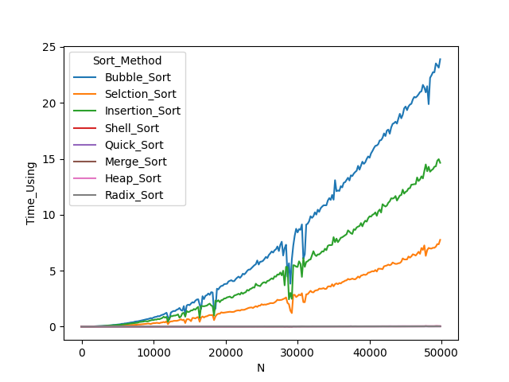
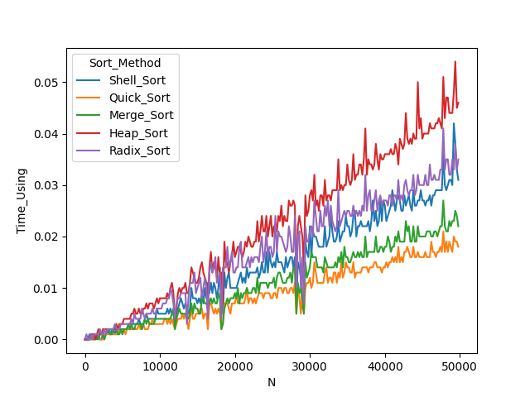

Conclusion
When the scale is large enough, bubble sort, selection sort, and insertion sort with O(n^2) complexity take significantly more time than other algorithms. And among the remaining 5 algorithms, merge sort and quick sort perform better.
Teacher’s Comments and Score
Comment：

Score： Signature：
Date：

